**Unlocking Success: A Data-Driven Analysis of Reading FC’s 2023/24 Season (8th Nov ’23)**

Introduction

In the midst of current challenges, Reading FC find themselves at the bottom of the league table. This analysis is driven by the desire to identify and address key areas where on-field performance can be enhanced. By delving into the detailed player statistics of Reading FC, we seek to unearth opportunities for strategic player selection and explore potential tactical innovations. As the team navigates the complexities of the 2023/24 season, this analysis aims not only to diagnose current issues but also to lay the groundwork for a transformative shift in performance. In examining the data, we endeavour to unveil insights that can propel Reading FC from the bottom of the league to a more promising and competitive standing.

Methodology

The primary data source for this analysis is the comprehensive statistics available on WhoScored (<https://www.whoscored.com/Teams/94/Show/England-Reading>) accessed on the 8th of November ’23. WhoScored is selected for its reliability and in-depth coverage of player performance metrics in football. The raw data was manually inputted into an Excel file. Subsequently, individual Python scripts were developed to extract and process specific areas of interest from the Excel dataset. This method ensures precision and flexibility in handling diverse player statistics considered in this analysis.

The decision to focus on certain variables, such as league stats and home vs away stats stems from the obvious disparity in performance. The combination of WhoScored data and customised Python scripts forms a robust foundation for our in-depth player performance analysis.

Objectives

League Performance Player Analysis

* Examine Reading FC players’ league performance, emphasising Goal Involvements, Vision + Ball Retention, and Aerial Duals. Assess whether the most successful players consistently contribute and explore the potential for varied player selection to enhance overall league form.

Home vs Away Performance Player Analysis

* Evaluate Reading FC players’ Home vs Away stats, with a specific focus on Passing, and Ball Control + Composure. Identify tactical opportunities and pinpoint players who can potentially bolster the team’s away performance.

League Standout Players

* Identify Reading FC’s top-performing players in the league to underscore their importance. Emphasize the significance of retaining these key players within the team for sustained success.

League Performance Player Analysis

Goal Involvements (Goals + Assists per 90 minutes)

This season, Reading FC have encountered a distinct challenge in finishing scoring chances. In response, our analysis focused on the team’s performance in the final third, specifically honing in on identifying the most impactful players through a dual-pronged approach. We scrutinised Goals + Assists per 90 minutes, while also taking into account the total minutes each player has played in league matches. By including players with fewer minutes, our goal is to uncover potential hidden gems who, despite limited playing time, showcase notable effectiveness, offering an alternative perspective on bolstering the team’s attacking prowess.

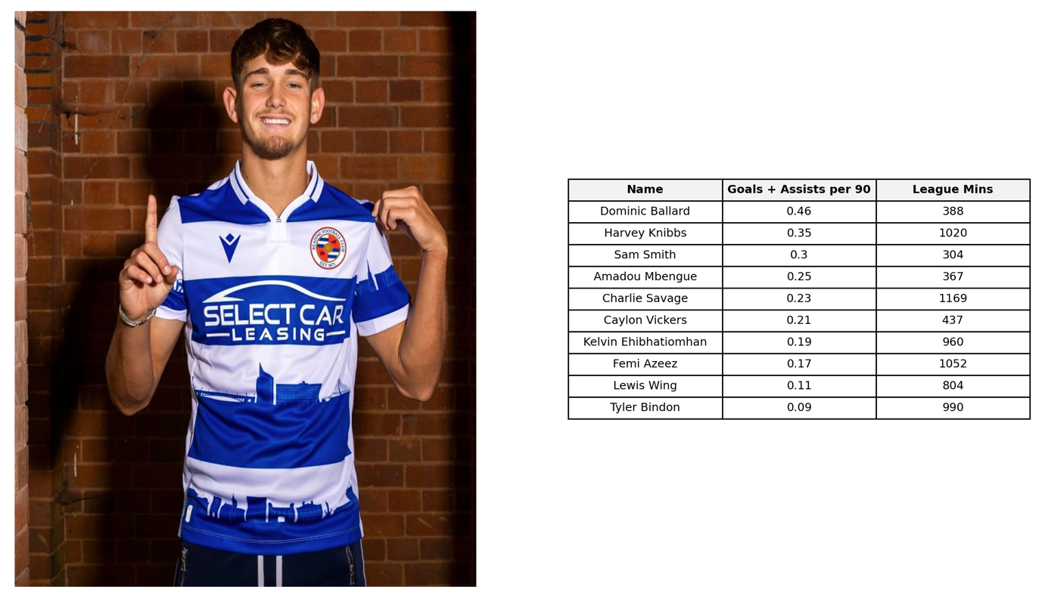

In examining player performances in the final third, Dominic Ballard emerges as the standout contributor, boasting an impressive 0.46 Goals + Assists per 90, translating to nearly a goal contribution every other game. Despite his notable impact, Ballard finds himself as the 15th most selected player, accumulating just 388 minutes on the pitch. This underutilisation of a player with superior attacking stats presents a compelling case for reconsidering his playing time, particularly in a team seeking to enhance its performance in the final third.

Another intriguing prospect is Amadou Mbengue, securing the 4th position with 0.25 Goals + Assists per 90, equating to a goal contribution once every 4 games. Despite being the highest placed defender, Mbengue sits as the 16th most selected player. Traditionally operating at right-back, an increased role for Mbengue could not only play to the team’s strengths in attacking down the wings but also align with the team’s overall style of play, particularly in attacking down the right flank.

Conversely, the performances of Kelvin Ehibhatiomhan and Femi Azeez, both attacking players, raise concerns. Despite accumulating significant minutes, their goal contributions are relatively poor. Considering this, and barring injuries, exploring more rotation with other attacking players like Ballard, Smith, and Vickers may offer the team an opportunity to find improved output and chemistry at the top end of the pitch.

Vision + Ball Retention

Next, we deep-dived into Reading FC players’ passing stats, focusing on 2 key aspects: passing percentage and key passes per game.

Passing percentage highlights players with excellent ball retention skills, a crucial element for effective game management, especially when protecting a lead. Improving ball retention not only allows Reading to dictate game tempo but also to help relieve pressure, particularly in challenging away fixtures where Reading have severely struggled this season.

Simultaneously, we assessed key passes per game to identify players adept at unlocking defences with vision, contrasting those who prioritise safer plays. The combination of passing percentage and key passes allows us to pinpoint players with both solid ball control and the ability to make incisive passes.

In this analysis, we also considered player minutes, providing insights into individuals who may deserve more playing time. This comprehensive approach helps us identify and nurture talented players who can elevate Reading FC’s on-field performance.

We can see that strong performers are Savage and Wing, who simultaneously look after the ball well while also managing to play key passes. They have both accumulated a decent amount of minutes and these findings warrant continued inclusion in the team.

In the bottom right, we can see very strong passing percentages for McIntyre, Holmes, Craig and Rushesha – all of whom have not managed many minutes this season. These are all central players, McIntyre and Holmes being centre-backs and Craig and Rushesha being central midfielders. Perhaps further inclusion for these players may see increased ball retention in central areas for Reading and allow for better control of matches.

For an increase in key passes, more inclusion for Elliott and Ballard has potential. We’ve already identified Ballard as having the best goal involvements per 90 minutes so this further reinforces his potential impact in the final third.

Perhaps the biggest surprise is Hutchinson who is traditionally a centre-back, this season playing his games in central midfield. We can see a strong ball retention while also displaying nearly 1 key pass per game. Hutchinson is also the oldest outfield player for Reading at 34 years old, so the combination of his experience and positive passing statistics make him a valuable player.

Finally, there is competition for the left-back position with 4 players currently fighting to claim a regular place in the team – Guinness-Walker, Carson, Mola and Dorsett. We can see all 4 have very different passing statistics. Guinness-Walker with the highest key passes per game of any player at left-back is incredibly impressive, however his passing percentage of 64.5% suggests his ball retention is poor. Carson manages nearly a key pass per game but his passing percentage is one of the worst in the squad at 59.6% with nearly every other pass going astray. By comparison, Mola and Dorsett don’t seem to play many key passes but do retain the ball better, Dorsett having the best passing percentage of the 4 at 75%. Perhaps these players strengths can be utilised depending on how the game is transpiring. If Reading are searching for better attacking output then Guinness-Walker is the obvious choice. If Reading are searching for better possession and control of the game then Dorsett may be the more adequate choice.

Aerial Duals

We can see another weakness of Reading is defending set pieces. Therefore, we analysed aerial duals won per game. Although there is more at play when it comes to defending set pieces, aerial prowess is a crucial aspect of defending one’s own penalty area.

Clearly, Reading’s most superior player in the air is Harlee Dean at 5.7 aerial duals won per game. Having Harlee Dean on the pitch will probably help Reading with defending set pieces. In pre match analysis, it would make sense to identify the opponent’s strongest aerial player and make sure Harlee Dean man marks this player from corners and free kicks. Tyler Bindon and Tom McIntyre at 4.3 and 3.0 aerial duals won per game respectively, may also add strong aerial reinforcement.

Sam Smith and Kelvin Ehibhatiomhan, 2 of Reading’s forwards, both have strong numbers. They may help the team both defensively and offensively, a valuable contribution for the team. They too can be chosen to mark the opponent’s strongest aerial players at set pieces. One of Reading’s few strengths is attacking down the wings. Knowing the aerial abilities of Smith and Ehibhatiomhan, it may be a good idea to target these players with crosses where they can contribute offensively too.

Caylon Vickers, a centre-forward, has accumulated 437 minutes and has not won 1 aerial dual. Therefore, it may be best to have him as an outlet further up the pitch when defending set-pieces, to initiate a counter attack if the opportunity arises. Jeriel Dorsett is an option at left back, so it is disappointing he has not won an aerial dual yet – however, he has only had 81 minutes, so perhaps with more playing time we will get a better reflection of his aerial ability. This is still of slight concern, so something to keep an eye on.

League Performance Player Analysis Summary

To summarise, we can see the potential for more varied player selection.

* More minutes for Dominic Ballard may improve goals, assists and key passes.
* For better threat down the right flank, the introduction of Amadou Mbengue may make an impact. On the opposite flank, Nesta Guinness Walker may equally have a similar impact.
* Continued inclusion for Charlie Savage and Lewis Wing will help continue varied pass types in central areas.
* We identified Harlee Dean as having superior aerial ability. When he is on the pitch, Reading may have better aerial prowess when defending set pieces. In the attacking third, Sam Smith and Kelvin Ehibhatiomhan can provide an aerial threat when going forwards.

Home vs Away Performance Player Analysis

When we compare Reading FC’s home and away form this season, it is clear to see there is a huge difference. We will decipher the statistical differences in player stats from at home compared to away.

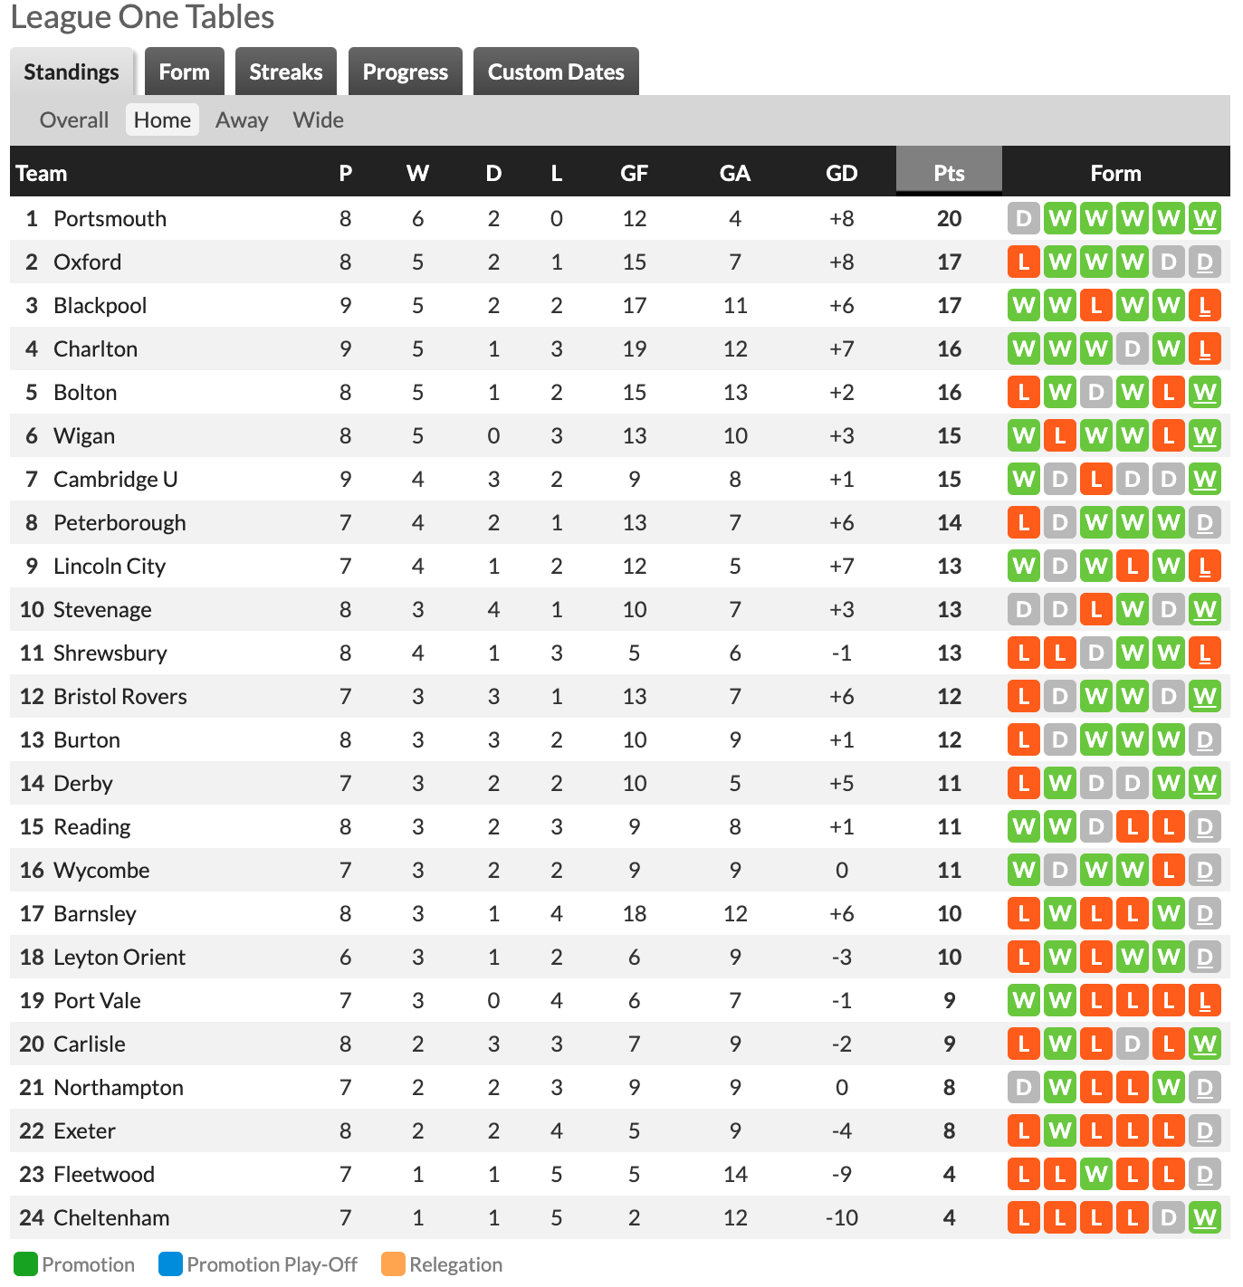

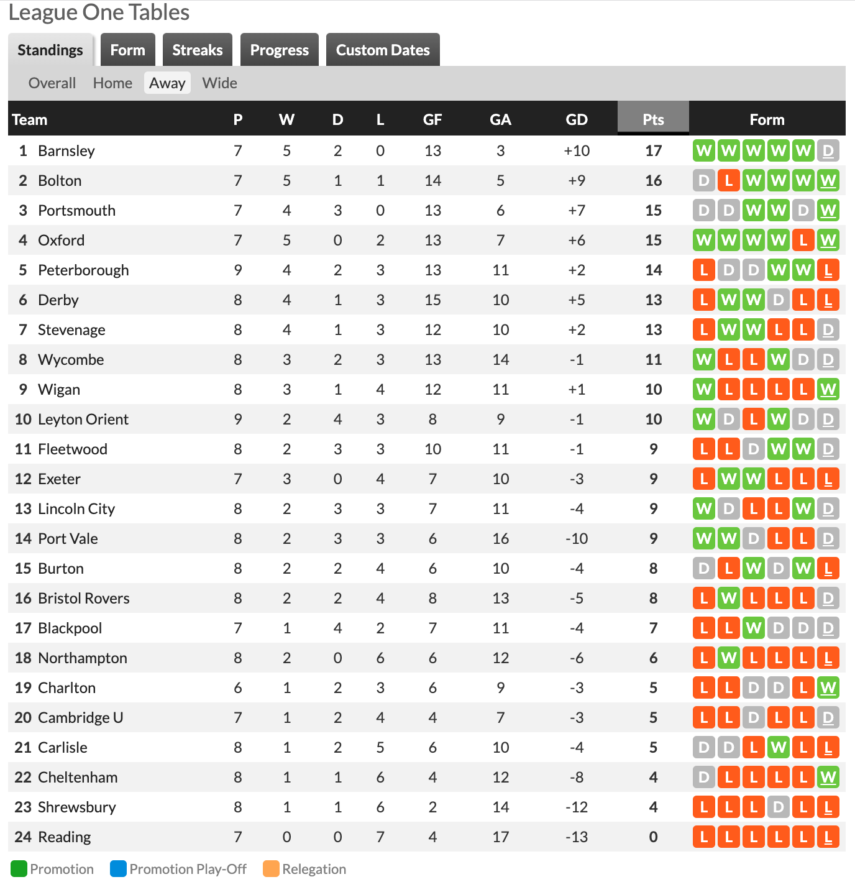

Goals scored at home are 9 compared to 4 away, more than double. Goals conceded at home are 8 compared to 17 away. Reading’s record at home is currently lower-mid table, showcasing some resilience and attacking ability and displaying a positive goal difference. Conversely, away Reading hold by far the worst record in the league, losing all 7 games so far, conceding the most goals and having the worst goal difference.

Passing

We start by analysing players who are on the ball more at home, compared to players who are on the ball more away.

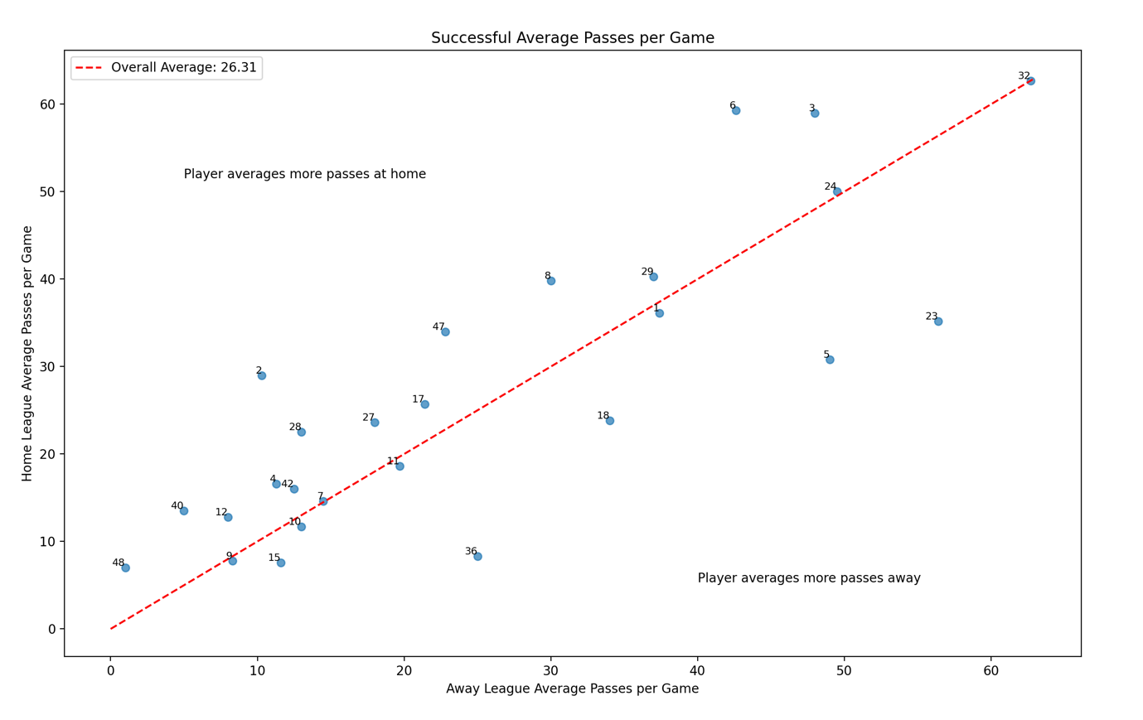

We can see that the player on the ball the most is number 32, Nelson Abbey. Abbey is a centre-back and plays largely safe passes. He is on the ball an equal amount at home to away. Fellow centre-back, Tyler Bindon (24) is on the ball equally as well. As to, is David Button the Goalkeeper. This suggests that build up play and ball retention in defensive areas is consistent both at home and away.

Although having less passes per game, having an equal amount of passes home vs away are quite a few attacking players. Femi Azeez (11), Harvey Knibbs (7), Sam Smith (10) and Dominic Ballard (9) are all just as involved in play at home as they are away. This shows a consistent execution of the way the team wants to play, whether they are at home or away. This is important to continue to build the team’s playing identity and to be able to impose Reading’s style of play, even when away.

The majority of players are on the ball more at home, which is to be expected. Players that stand out as getting on the ball more at home are Thomas Holmes (3), Harlee Dean (6), Charlie Savage (8), Matthew Carson (47) and Clinton Mola (2). These are 4 defenders and Charlie Savage, who plays as a deep lying playmaker at home. We know from our earlier analysis that Savage is Reading’s best passer, being able to look after the ball well while also managing to play key passes. Perhaps there needs to be a tactic to bring Savage into play more away from home, his ball retention and key passes will surely help relieve pressure as well as pose a threat going forwards.

Players who are on the ball more away are Sam Hutchinson (23), Tom McIntyre (5), Nesta Guinness Walker (18) and Michael Craig (36). We can see from earlier analysis that Hutchinson, McIntyre and Craig have some of the best ball retention of the whole squad, perhaps teammates trust them to look after the ball in tight areas away. Guinness Walker has low ball retention and high key passes, suggesting that he is Reading’s outlet away. He averages 1.3 key passes per game but has registered 0 assists. So even though he is Reading’s outlet away, it seems the attacking play breaks down somewhere along the way. Perhaps there could be work on the training pitch to help build the relationships between Guinness Walker and players in the final third.

Ball Control + Composure

Next, for each player we analysed bad touches per game at home and away. We did this to see perhaps which players were inviting more pressure away. One of Reading’s weaknesses is avoiding individual errors.

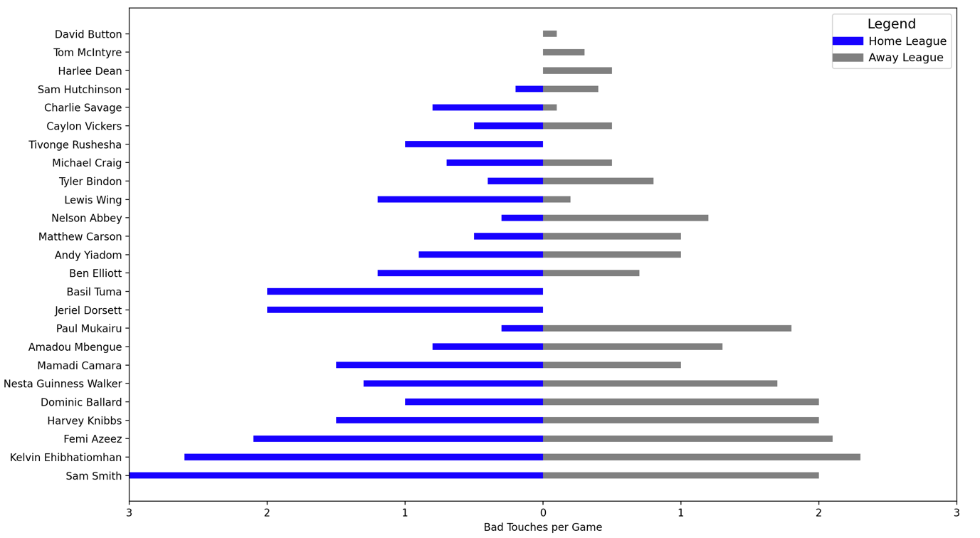

What is interesting from this analysis is that there seem to be just as many bad touches at home as there is away. Perhaps we can draw from this that bad touches are not dependent on whether the player is at home or away. There must be other factors involved why they have a bad touch. Therefore further analysis on bad touches may be required to fully understand.

There is a spread of defensive and attacking players. Defensive players McIntyre and Dean control the ball very well, however, there seems to be more than 1 bad touch per game for Guinness Walker and Mbengue. Vickers controls the ball well, but his attacking counterparts Smith, Ehibhatiomhan and Ballard don’t fare so well. Perhaps there can be a focus in training to help certain players develop their ball control skills? Perhaps Reading can look through video analysis how McIntyre, Dean and Vickers receive the ball compared to their counterparts?

The biggest difference is Paul Mukairu. He averages 0.3 bad touches per game at home, compared to 1.8 bad touches away. Why could there be such a big difference? Perhaps there could be a focus in training to help Mukairu controlling the ball under pressure? Or a training plan to help him keep his composure in away atmospheres?

Player Selection

Next we looked at the minutes players had played at home compared to away. Due to the significant difference in home vs away form, the idea was to see if large disparities in player selection could play a part.

We can see that the player who has featured the most at home is Charlie Savage, on the pitch for 97.2% at home. Interestingly, he has only featured 74.4% away. We learnt from our earlier analysis that Savage is Reading’s best passer but is not able to get on the ball as much away. We can see here that this perhaps leads to him being substituted or not selected. Again, perhaps further emphasis that Savage can be a key to improving away form, by keeping him on the pitch and getting him on the ball more.

We know that at home Reading are more effective in both attacking and defending.

2 defenders featuring at home a lot more are Tyler Bindon and Andy Yiadom. 3 defenders featuring a lot more away are Nelson Abbey, Harlee Dean and Matthew Carson.

Attackers featuring more at home are Sam Smith and Mamadi Camara. Compared to attackers featuring more away like Azeez, Ehibhatiomhan, Vickers and Ballard.

Perhaps there can be an analysis as to what players are doing at home compared to what their counterparts are doing differently away?

In Reading’s style of play it is noted that they ‘rotate their first eleven’. When we look at the table above, what stands out is that there aren’t many players who have an equal involvement at home and away. They’re either more heavily involved in one or the other. Perhaps it would benefit the team more to have a more consistent eleven, so when they go away, everyone knows their roles on the pitch and they can begin to forge relationships with other players helping link up. Inconsistent team selection may be resulting in inconsistent performances and results.

Home vs Away Performance Player Analysis Summary

* In passing, defensive players like Nelson Abbey and Tyler Bindon maintain consistency in ball possession, and attacking players like Femi Azeez remain involved both at home and away. However, key player Charlie Savage is more influential at home, suggesting the need for a tactical adjustment in away matches.
* In terms of ball control, bad touches are a concern for both home and away games, with Paul Mukairu, showing a significant difference. Targeted training may improve his performance under pressure.
* Player selection reveals Charlie Savage features more at home, potentially impacting away form. A more consistent starting eleven, with key players emphasised in both settings, could contribute to improved team performance, as inconsistent selection may be a factor in varying results.

League Standout Players

Summary

Reading FC’s 2023/24 season analysis reveals critical insights for performance improvement. The league performance analysis highlights the underutilisation of impactful players like Dominic Ballard and Amadou Mbengue, suggesting potential gains from varied player selection. The focus on goal involvements, vision, and ball retention identifies key contributors, urging reconsideration of player roles for enhanced attacking prowess.

Examining passing, ball control, and composure, players like Savage and Wing shine, emphasising their importance in maintaining possession. Aerial duals analysis pinpoints Harlee Dean’s superiority, offering strategic advantages in defensive set-pieces. The comprehensive evaluation advocates for a nuanced approach to player selection and strategic utilisation of strengths in different game scenarios.

Home vs Away performance disparities underscore the need for tactical adjustments. While certain players maintain consistency in ball involvement, key player Charlie Savage’s higher influence at home prompts a call for strategic revisions in away matches. The analysis of bad touches emphasises the importance of targeted training, particularly for players like Paul Mukairu.

Player selection insights reveal a discrepancy in Charlie Savage’s participation at Home vs Away, advocating for a more consistent starting eleven. The inconsistency in team selection is identified as a potential factor contributing to varying performances and results.

In summary, the data-driven analysis suggests a transformative shift in Reading FC’s approach is possible, emphasising varied player selection, strategic adjustments based on player strengths, and a more consistent starting eleven to foster team chemistry and improve overall performance.